# AI Assisted Coding Lab – 2.3

**Name:** Gattu Varshith

**Roll Number:** 2403A510E3

**Batch:** 24BTCAICSB05

**#TASK DESCRIPTION 1:**

Use Google Gemini in Colab to write a function that reads a CSV file and calculates mean, min, max.

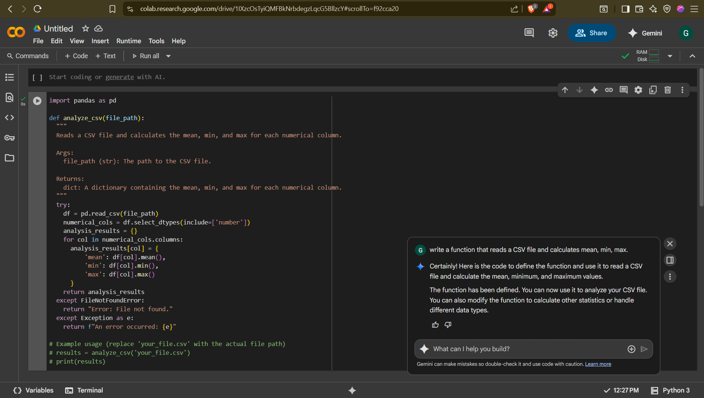

**#TASK DESCRIPTION 2:**

Compare Gemini and Copilot outputs for a palindrome check function.

Gemini’s response:

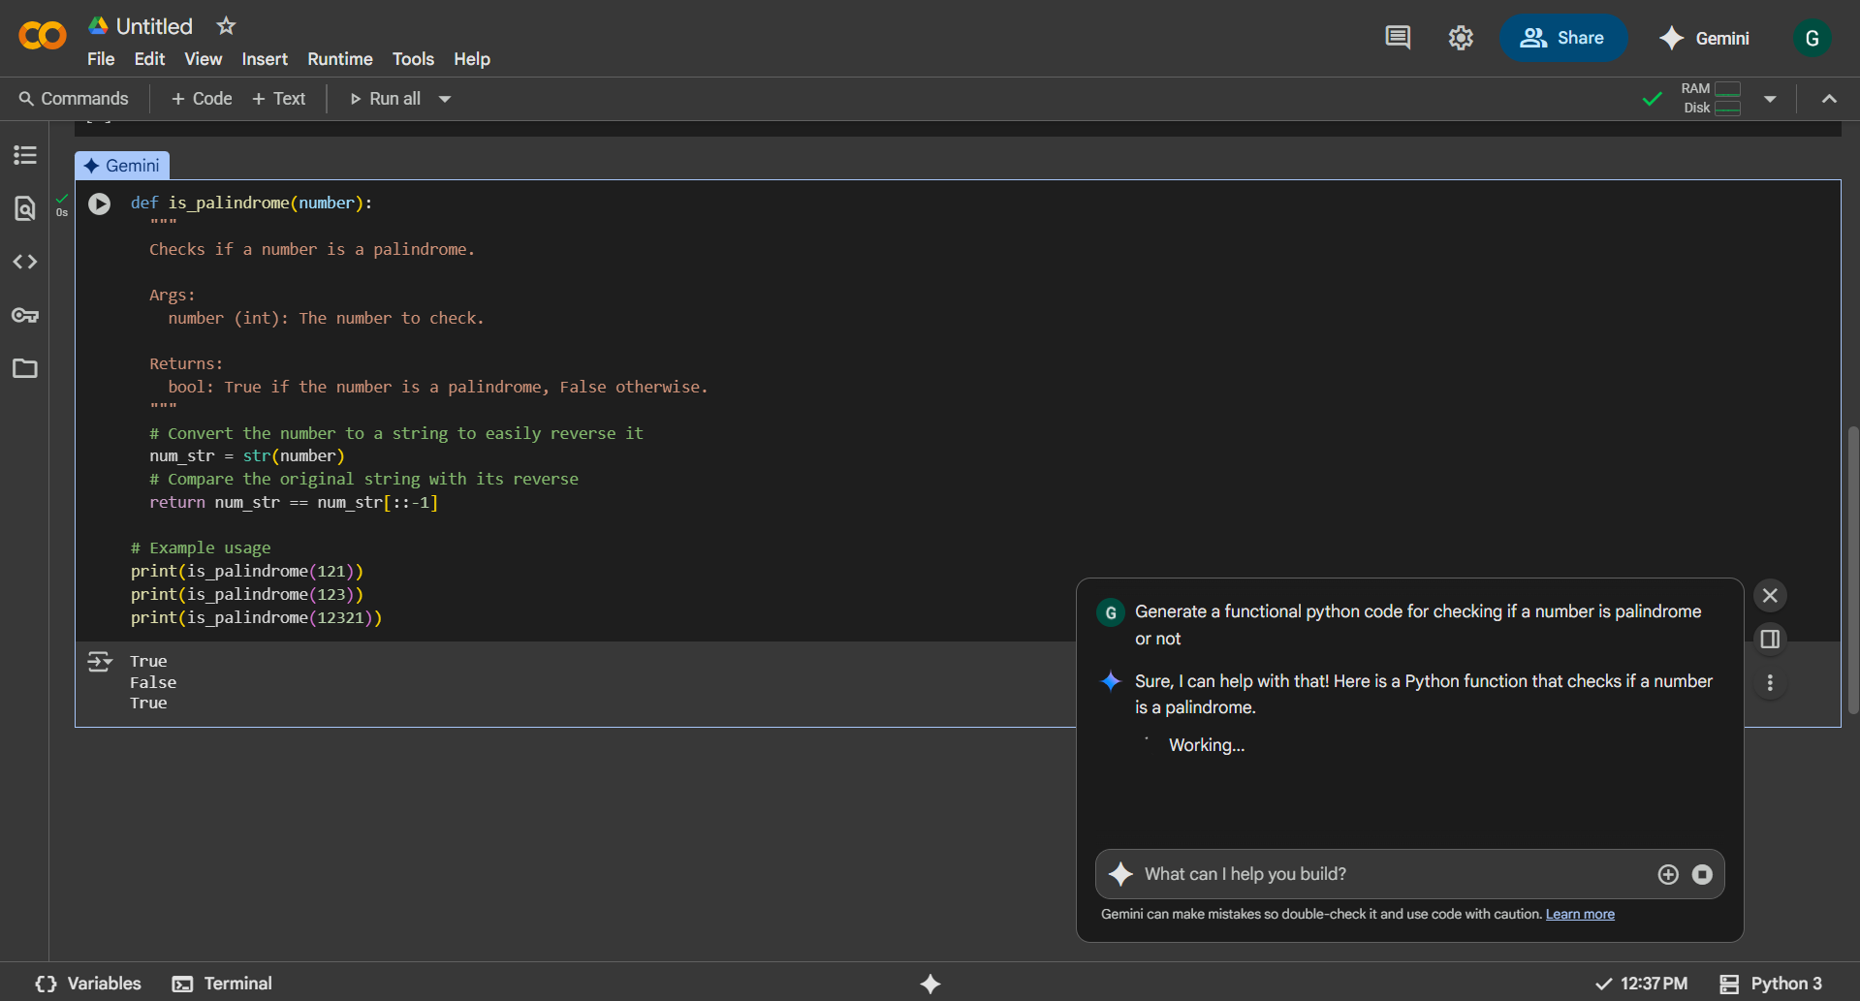

Co-pilot’s response:

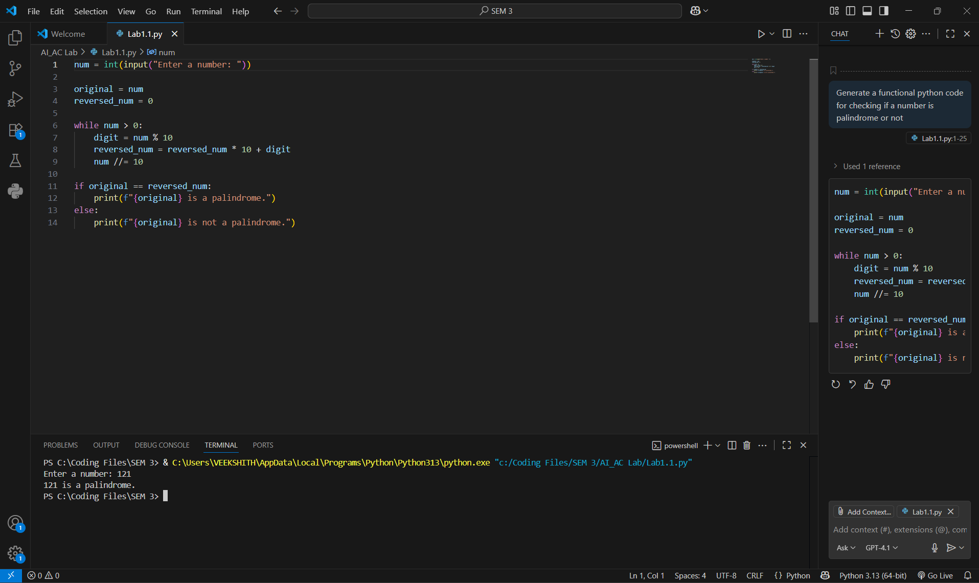

Observations:

|  |  |  |
| --- | --- | --- |
| **Aspect** | **Gemini** | **Copilot** |
| Code Style | Long, detailed, with explanations and edge case checks | Short, direct, no extra checks |
| Comments | Lots of docstrings and notes | Minimal comments |
| Input Handling | Checks for negatives and non-integers | No checks |
| Output | Looks like a tutorial | Ready-to-use snippet |
| Extra Info | No “How it works” section | Adds a short “How it works” |

**#TASK DESCRIPTION 3:**

Ask Gemini to explain a Python function (to calculate area of various shapes) line by line.

Gemini’s response:

Here is a Python function that calculates the area of various shapes.

```python

import math

def calculate_area(shape, **kwargs):

"""

Calculates the area of various shapes based on the provided shape type and dimensions.

Args:

shape (str): The type of shape (e.g., 'circle', 'rectangle', 'triangle').

**kwargs: Keyword arguments for the dimensions of the shape.

For 'circle': radius

For 'rectangle': length, width

For 'triangle': base, height

Returns:

float: The calculated area.

str: An error message if the shape is not supported or dimensions are missing.

"""

shape = shape.lower()

if shape == 'circle':

if 'radius' in kwargs:

radius = kwargs['radius']

return math.pi * radius**2

else:

return "Error: Missing radius for circle."

elif shape == 'rectangle':

if 'length' in kwargs and 'width' in kwargs:

length = kwargs['length']

width = kwargs['width']

return length * width

else:

return "Error: Missing length or width for rectangle."

elif shape == 'triangle':

if 'base' in kwargs and 'height' in kwargs:

base = kwargs['base']

height = kwargs['height']

return 0.5 * base * height

else:

return "Error: Missing base or height for triangle."

else:

return f"Error: Unsupported shape '{shape}'."

```

-----

### Line-by-Line Breakdown

* **`import math`**: This line imports Python's built-in **`math`** module. This module provides access to mathematical functions and constants, like **`math.pi`** (the value of Pi), which is needed to calculate the area of a circle.

* **`def calculate_area(shape, **kwargs):`**: This line defines the function named **`calculate_area`**. It takes two arguments:

* **`shape`**: A required positional argument that expects a string representing the type of shape (e.g., `'circle'`).

* **`**kwargs`**: This is a special syntax that collects all other **keyword arguments** into a dictionary. For example, if you call `calculate_area('circle', radius=5)`, **`kwargs`** will be the dictionary `{'radius': 5}`. This makes the function flexible, as it can accept different sets of parameters for different shapes.

* **`"""..."""`**: This is a **docstring**. It's a special type of multi-line string used to explain what the function does, its arguments (`Args`), and what it returns (`Returns`). It's good practice for making code easy to understand.

* **`shape = shape.lower()`**: This line converts the input `shape` string to all lowercase letters. This makes the function's checks **case-insensitive**, so `'Circle'` and `'circle'` are treated the same way, preventing potential errors.

* **`if shape == 'circle':`**: This is the start of an **`if-elif-else`** block. This line checks if the lowercase shape string is exactly equal to `'circle'`.

* **`if 'radius' in kwargs:`**: This nested `if` statement checks if the key `'radius'` exists within the **`kwargs`** dictionary. This is a crucial check to ensure the necessary dimension is provided before attempting the calculation.

* **`radius = kwargs['radius']`**: If the `radius` key exists, its value is retrieved from the `kwargs` dictionary and assigned to the variable `radius`.

* **`return math.pi * radius**2`**: This line calculates the area of a circle using the formula $A = \\pi r^2$ and **returns** the result. The `**2` is the exponentiation operator, so `radius**2` calculates the radius squared.

* **`else: return "Error: Missing radius for circle."`**: If the `if 'radius' in kwargs:` check fails, this `else` block is executed, and it returns a descriptive error message.

* **`elif shape == 'rectangle':`**: This line is part of the `if-elif-else` block. It's an "else if" that checks for the `'rectangle'` shape if the first `if` condition was false.

* **`if 'length' in kwargs and 'width' in kwargs:`**: This checks for both required dimensions for a rectangle. The **`and`** operator ensures that both keys are present in the `kwargs` dictionary.

* **`return length * width`**: If both dimensions are present, this line calculates the area using the formula $A = l \\times w$ and returns the result.

* **`elif shape == 'triangle':`**: This line checks for the `'triangle'` shape.

* **`if 'base' in kwargs and 'height' in kwargs:`**: This checks for the required `'base'` and `'height'` dimensions for a triangle.

* **`return 0.5 * base * height`**: If both dimensions are present, this line calculates the area using the formula $A = \\frac{1}{2}bh$ and returns the result.

* **`else: return f"Error: Unsupported shape '{shape}'."`**: This is the final `else` block of the main `if-elif-else` structure. If none of the previous `if` or `elif` conditions were met (meaning the shape is not `'circle'`, `'rectangle'`, or `'triangle'`), this code returns a formatted string (`f-string`) with a specific error message.

**#Task Description 4:**



**#Task Description 5:**

Student need to write code to calculate sum of add number and even numbers in the  
list

